**Core Java Assignment 2**



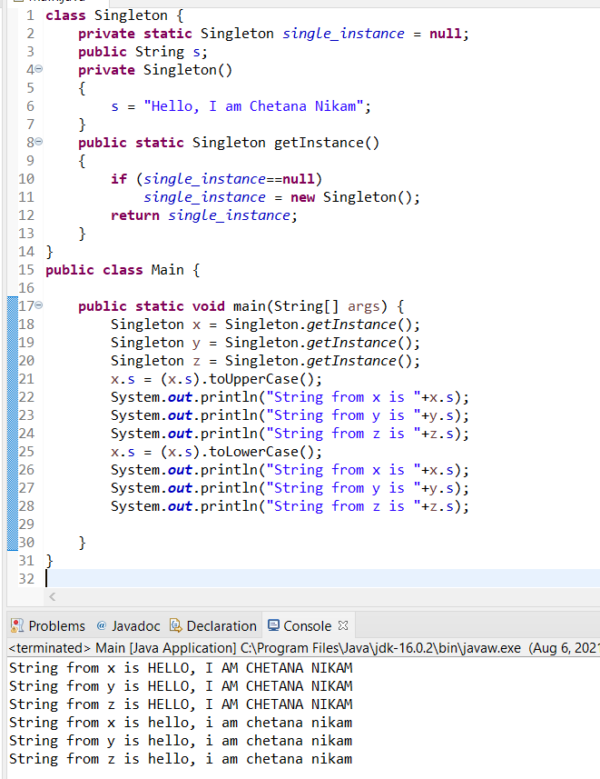

**2.**

**class** Employee {

**int** employeeId;

String employeeName;

**double** salary;

**public** Employee(**int** employeeId, String employeeName, **double** salary) {

**super**();

**this**.employeeId=employeeId;

**this**.employeeName=employeeName;

**this**.salary=salary;

}

**public** **int** getEmployeeId() {

**return** employeeId;

}

**public** **void** setEmployeeId(**int** employeeId) {

**this**.employeeId=employeeId;

}

**public** String getEmployeeName() {

**return** employeeName;

}

**public** **void** setEmployeeName(String employeeName) {

**this**.employeeName=employeeName;

}

**public** **double** getSalary() {

**return** salary;

}

**public** **static** **class** Manager **extends** Employee{

**public** **static** **final** **double** ***Bonusrate***=0.2;

**public** Manager(**int** employeeId, String employeeName, **double** incentive) {

**super**(employeeId, employeeName, incentive);

}

**public** **double** getSalary() {

**return** salary+salary\****Bonusrate***;

}

}

**public** **static** **class** Labour **extends** Employee{

**public** **static** **final** **double** ***Bonusrate***=0.1;

**public** Labour(**int** employeeId, String employeeName, **double** salary) {

**super**(employeeId, employeeName, salary);

}

**public** **double** getSalary() {

**return** salary+salary\****Bonusrate***;

}

}

}

**public** **class** MethodOverridingMain {

**public** **static** **void** main(String[] args) {

Employee.Labour l1=**new** Employee.Labour(1, "Prakash", 3000);

Employee.Labour l2=**new** Employee.Labour(2, "Krishna", 4000);

Employee.Manager M1=**new** Employee.Manager(3, "Sujit", 80000);

Employee.Manager M2=**new** Employee.Manager(4, "Ketan", 75000);

System.***out***.println("Name of Employee: "+l1.getEmployeeName()+" id no: "+l1.getEmployeeId()+" Salary: "+l1.getSalary());

System.***out***.println("Name of Employee: "+l2.getEmployeeName()+" id no: "+l2.getEmployeeId()+" Salary: "+l2.getSalary());

System.***out***.println("Name of Employee: "+M1.getEmployeeName()+" id no: "+M1.getEmployeeId()+" Salary: "+M1.getSalary());

System.***out***.println("Name of Employee: "+M2.getEmployeeName()+" id no: "+M2.getEmployeeId()+" Salary: "+M2.getSalary());

}

}

**Output:**

Name of Employee: Prakash id no: 1 Salary: 3300.0

Name of Employee: Krishna id no: 2 Salary: 4400.0

Name of Employee: Sujit id no: 3 Salary: 96000.0

Name of Employee: Ketan id no: 4 Salary: 90000.0

**3.**

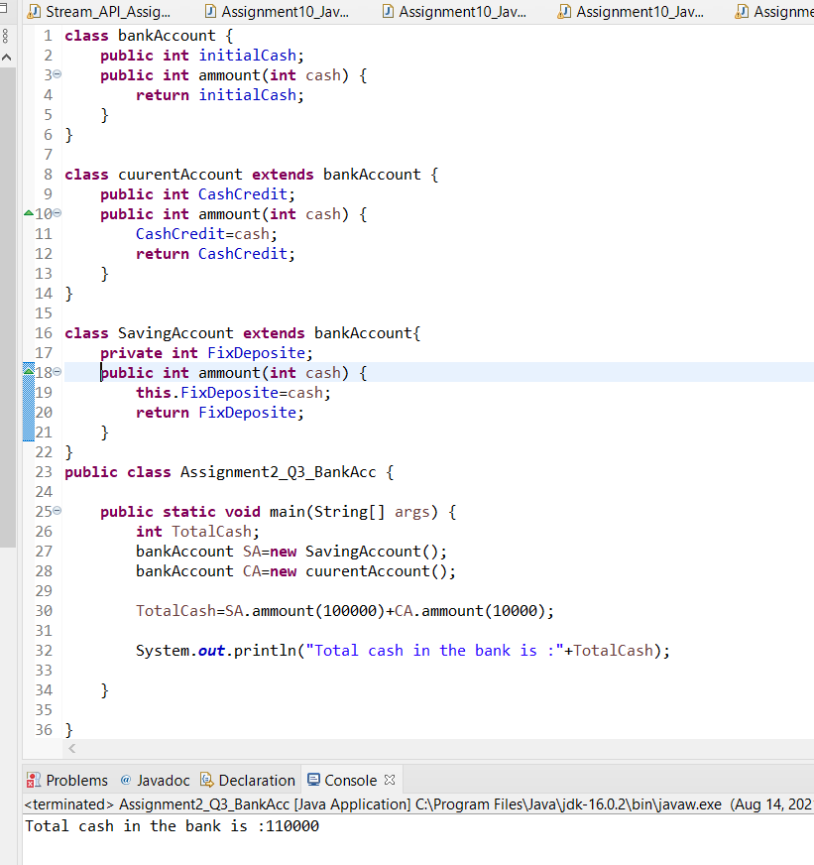

**4.**

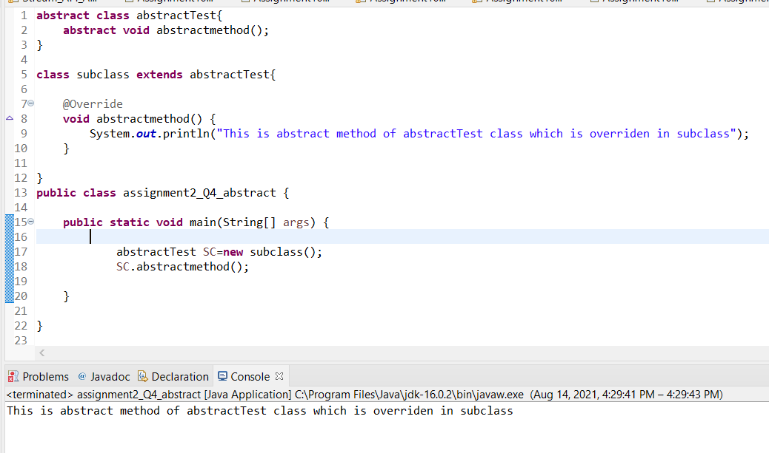

**5.**

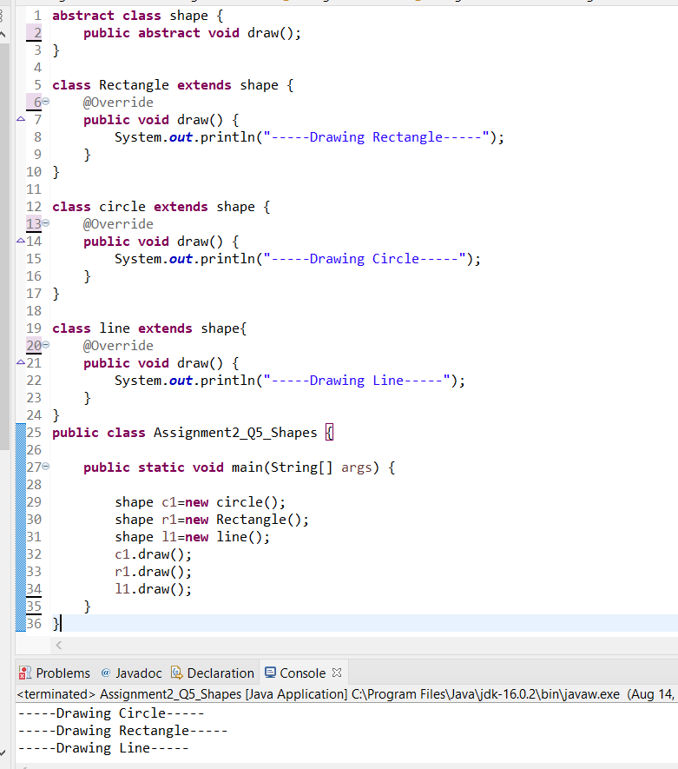

**6.**

